A picture containing clipart

Description generated with very high confidence

Hands-on

Creating an OpsWorks Stack

UNIX/Linux Training

[**support@intellipaat.com**](mailto:support@intellipaat.com)

**+91-7022374614**

**US: 1-800-216-8930(Toll Free)**

**Creating an OpsWorks Stack**

**Step 1:** Go to the OpsWorks console and choose Add your first stack

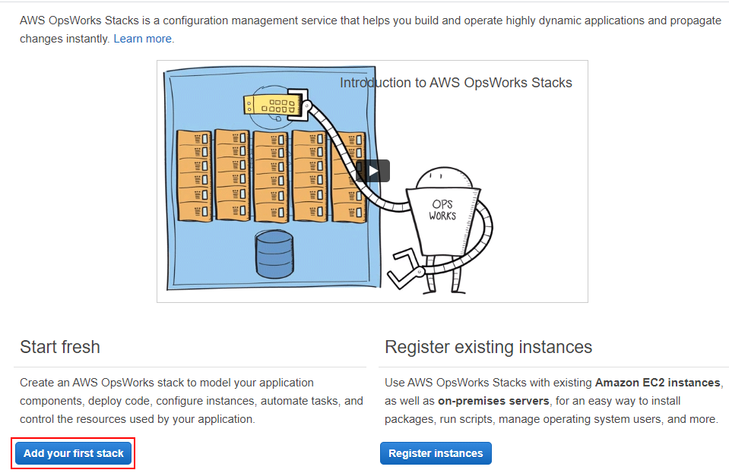

**Step 2:** Go ahead with the Sample stack and hit Create stack

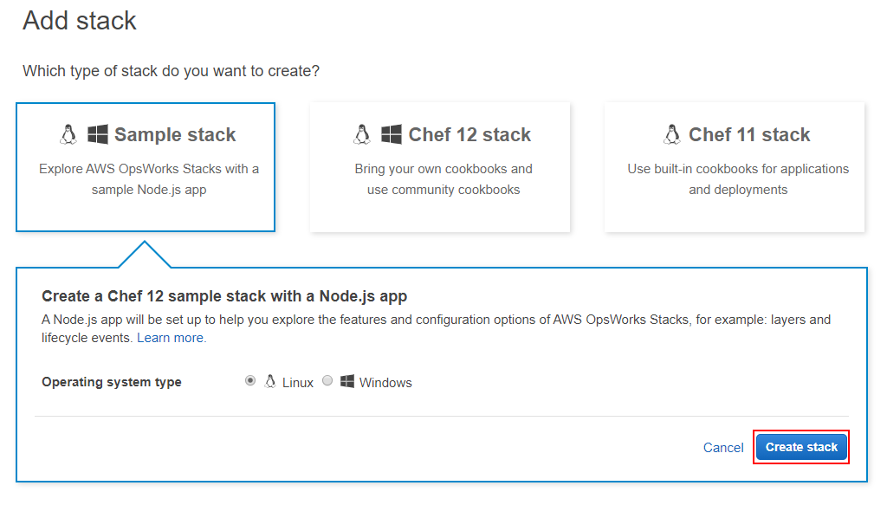

**Step 3:** Check if all the steps are successful. If all the steps have a green tick, then click Explore the sample stack

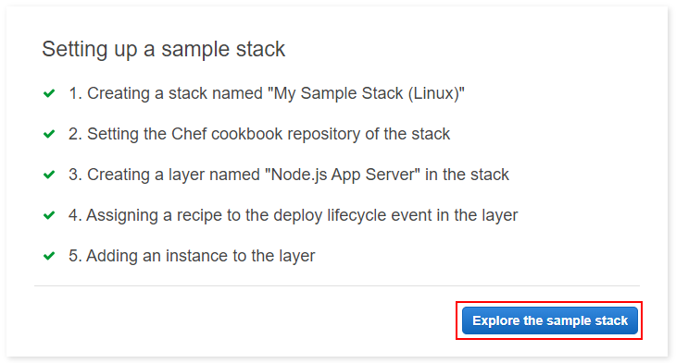

**Step 4:** This is how your Dashboard will look

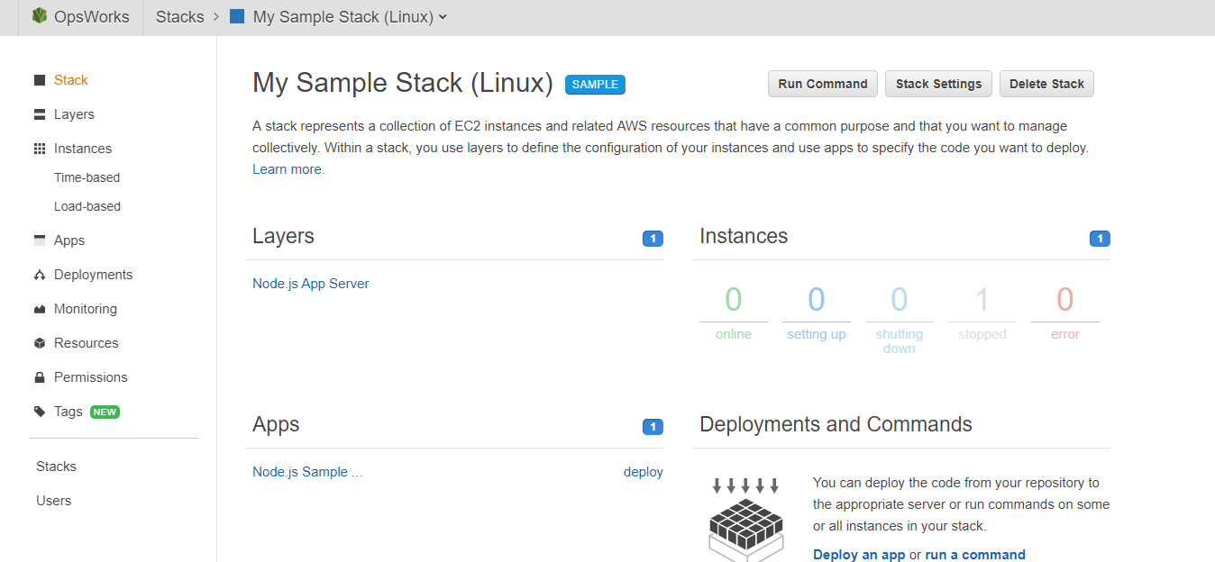

**Step 5:** Now, we must configure the instances. Before starting the instance, change the instance type from t2.medium to t2.micro so that you won’t get billed. Click instances then click on the name of the Node.js server.

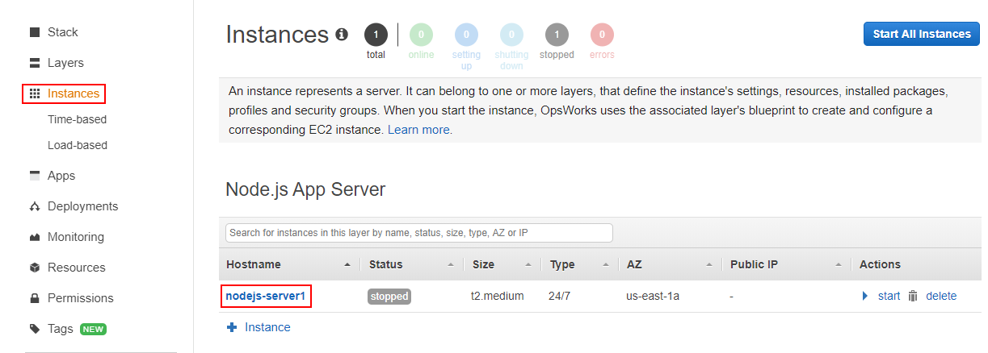

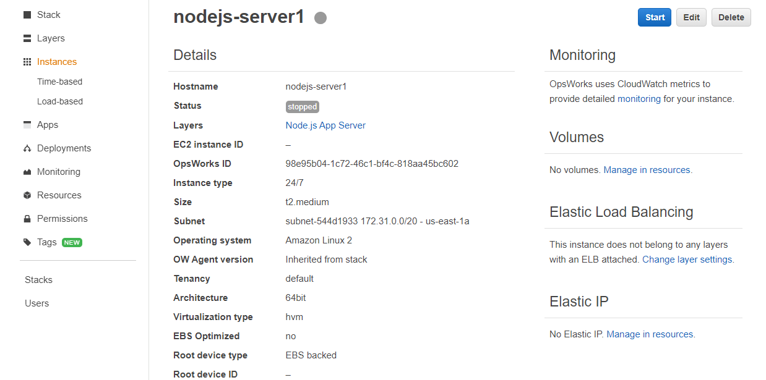

**Step 6:** Click on the edit button on the top-right of the page. Under size, choose t2.micro and hit Save.

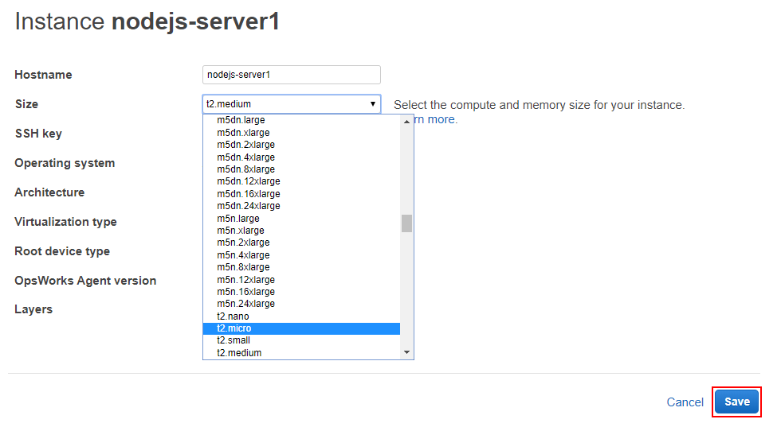

**Step 7:** Now click the start button. The Status will change from stopped to requested.

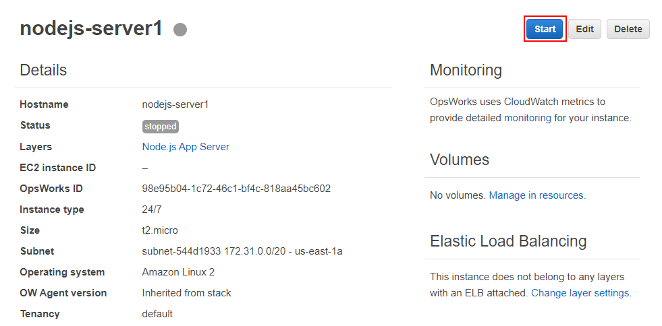

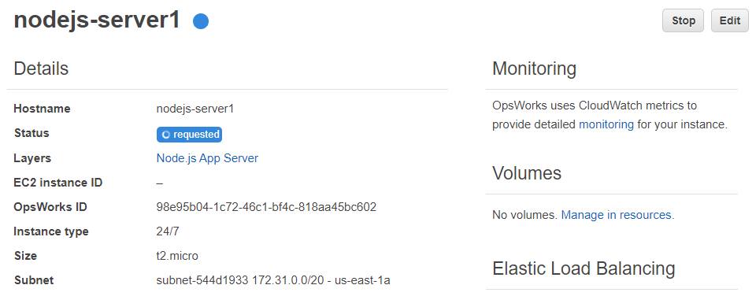

**Step 8:** Wait until the Status changes to Online. Now you can see there is an EC2 instance launched by clicking on the EC2 instance ID. If you go further down, you will get the public IP address of the instance. By running it on your browser, you will be able to view the Node.js application. Use the Public DNS or Public IP.

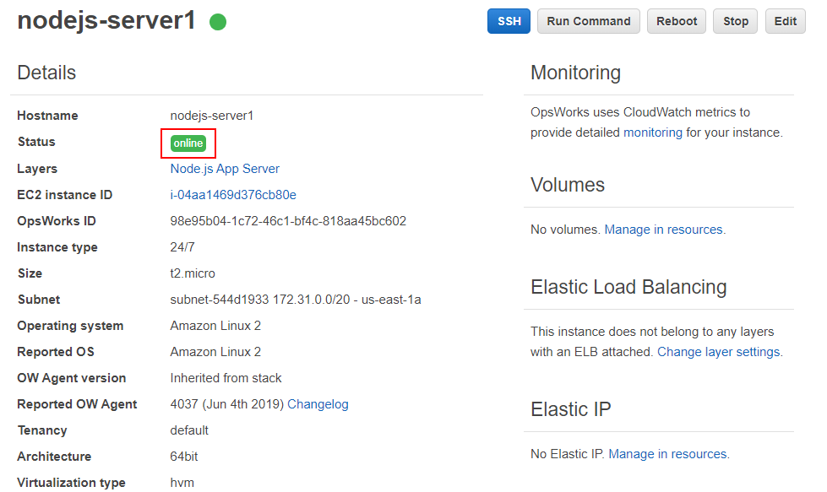

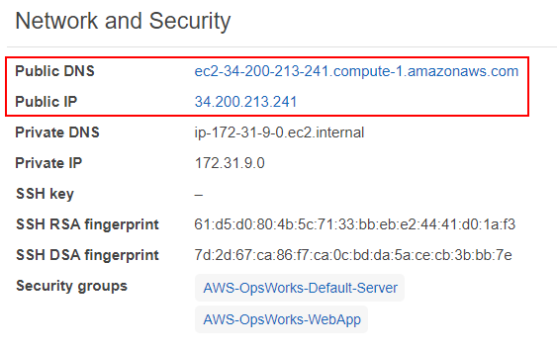

**Step 9:** This would be the output.

